**ASSIGNMENT-4**

**DISTANCE DETECTION USING ULTRASONIC SENSOR**

Arunagiri.V( 19110008)

Question1 :

Write code and connections in wokwi for ultrasonic sensor. Whenever distance is less than 100 cms send "alert" to ibm cloud and display in device recent events.

CODE :

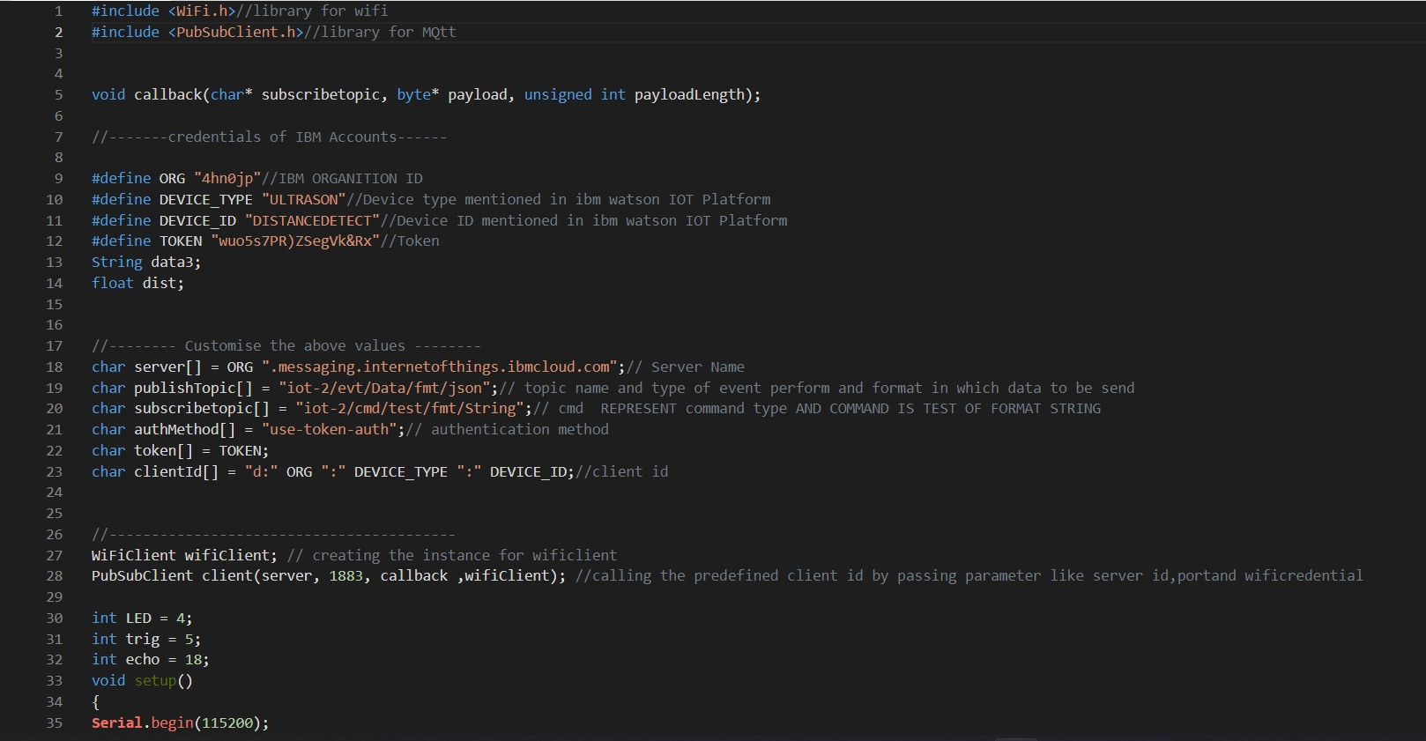

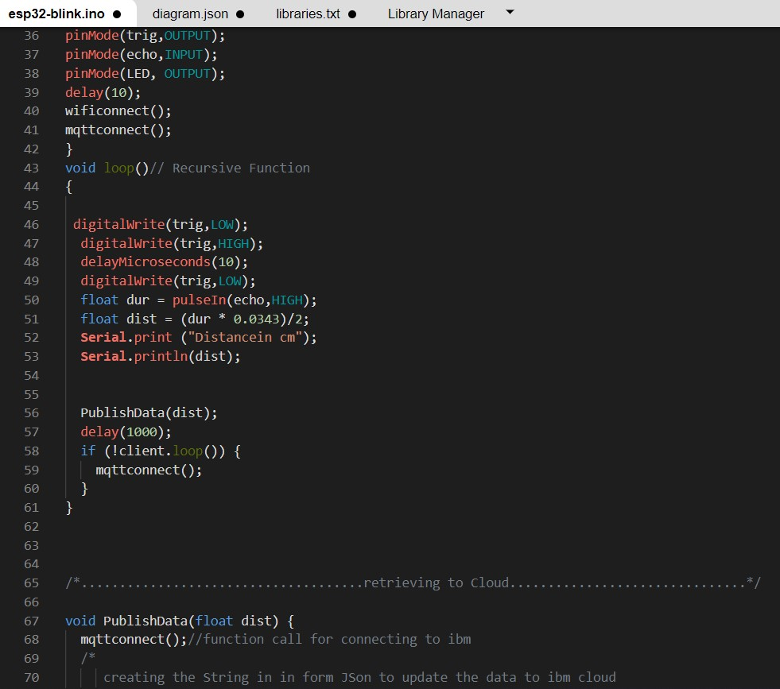

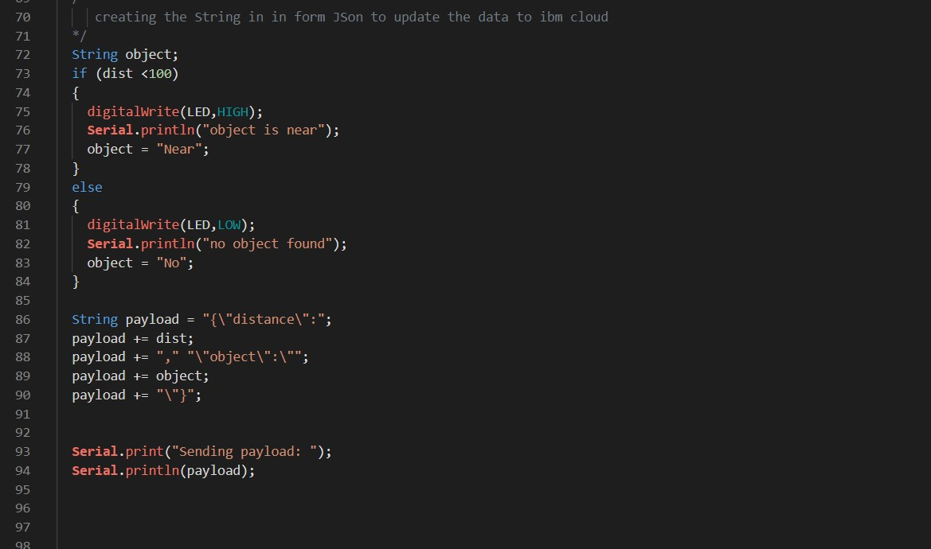

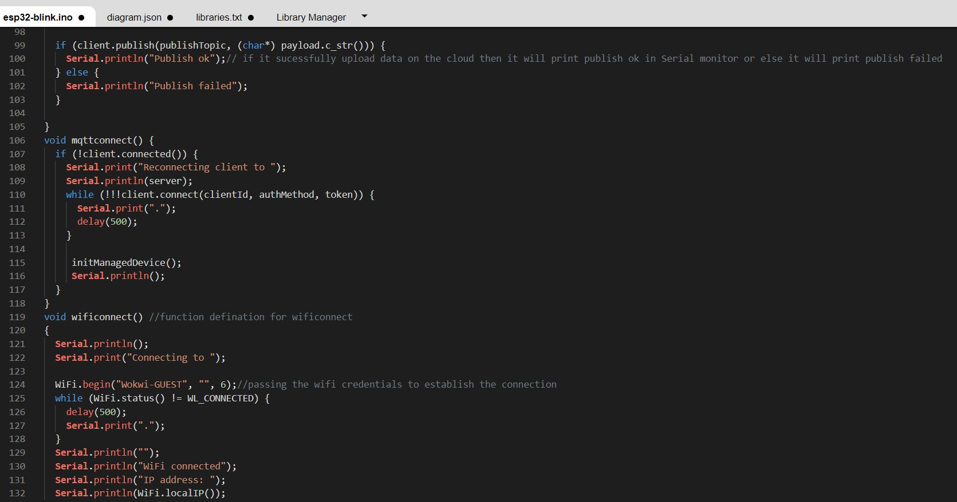

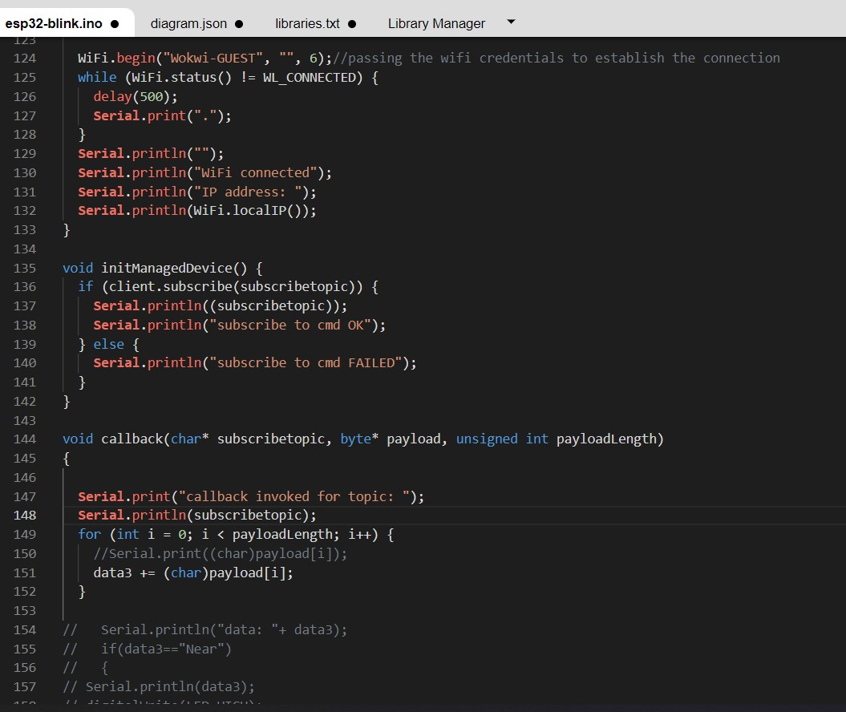

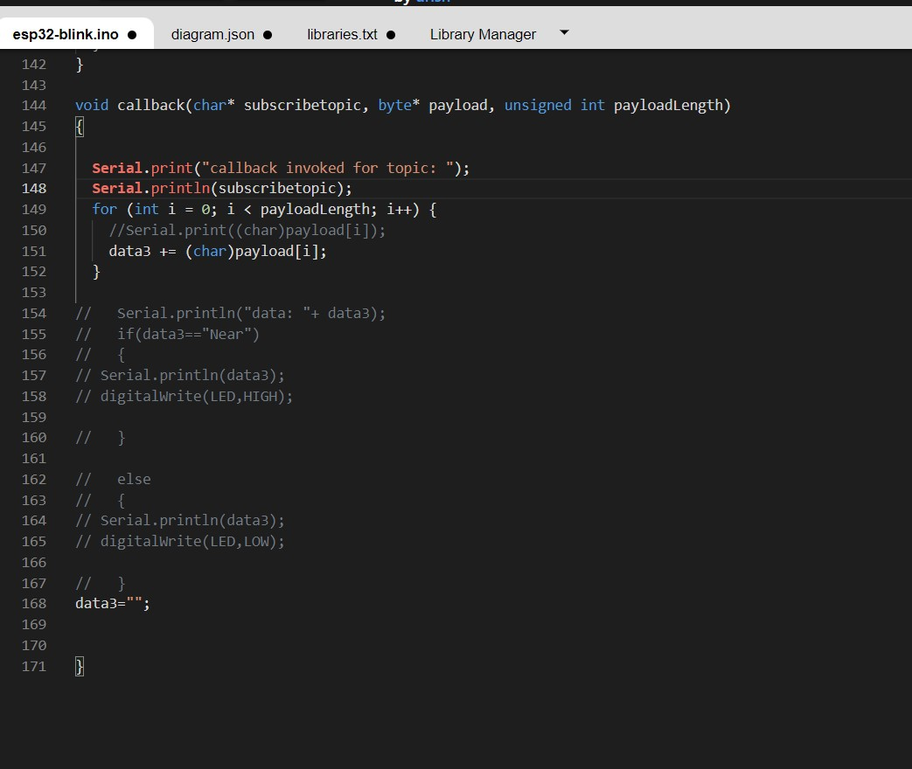

OUTPUT:

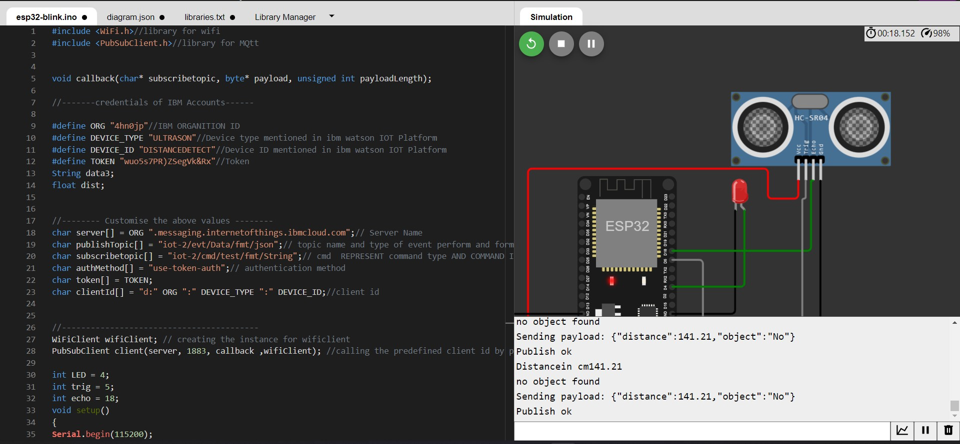

# Data send to the IBM cloud device when the object is far

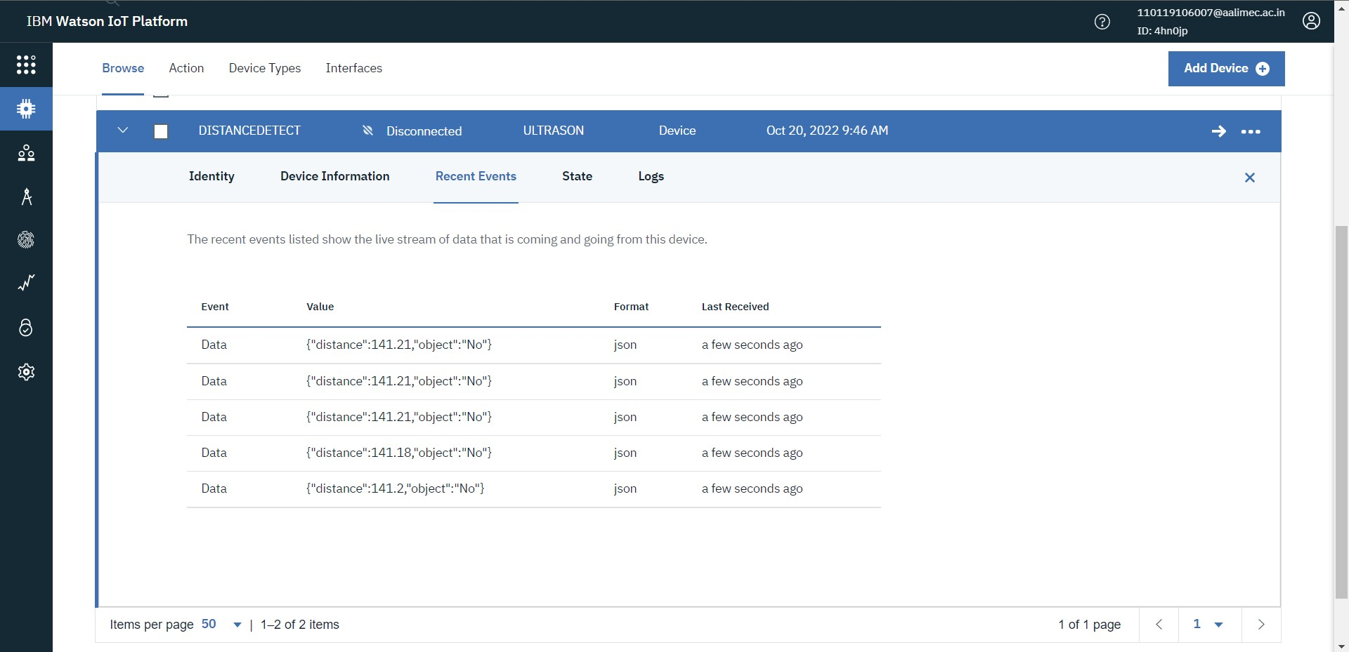

# when object is near to the ultrasonic sensor

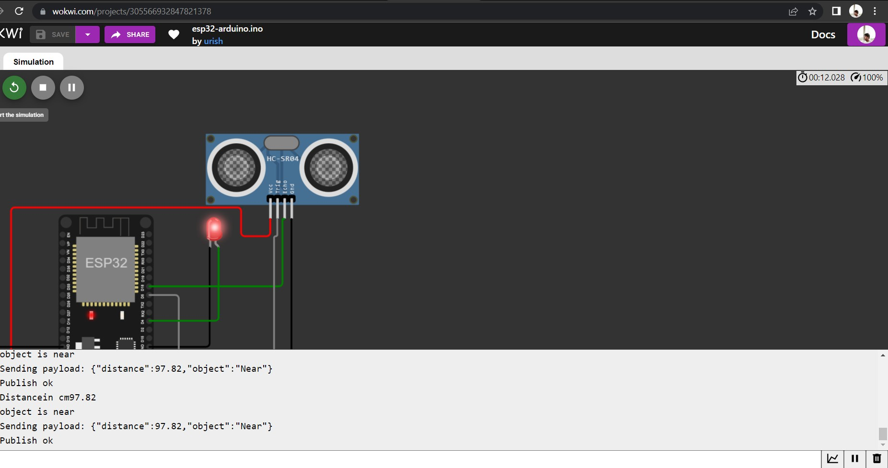

# Data sent to the IBM Cloud Device when the object is near

